INDIA & NEPAL
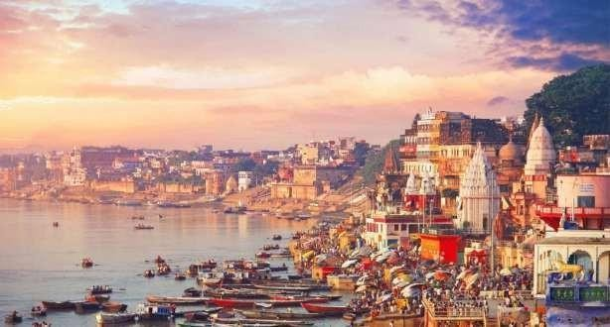
Circuito: Delhi – Delhi – Agra – Fatehpur SIkri – Jaipur – Pushkar – Jodhpur – Ranakpur
Udaipur – Delhi – Kathmandu
ITINERARIO PUBLICADO:

DÍA 00: | ESPAÑA – DELHI
DÍA 02: | ARRIVAL DELHI

Arrival at the airport 3 hours before departure for check-in on a scheduled Turkish Airlines flight to Delhi, with a layover in Istanbul. Overnight flight.

Upon arrival, our representative will meet you and take you to the hotel for breakfast and to leave your luggage. Depending on hotel availability, we will either check in immediately or begin our tour of Old Delhi. At the scheduled time, we will visit Old Delhi, including the Jama Masjid mosque (the largest in the country), and stop at the Red Fort, one of the most opulent from the Mughal Empire era. We will take a rickshaw ride through the narrow streets. We will then continue to Raj Ghat (Gandhi's memorial). Afterwards, we will return to the hotel to check in. Dinner and overnight stay..

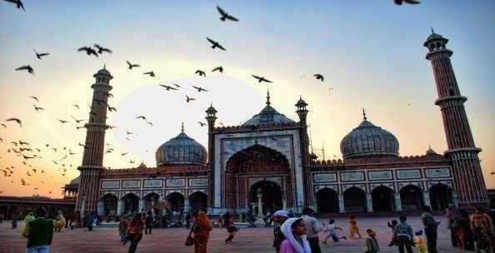

DÍA 03: | DELHI
Discover the contrasting charms of India’s capital on this enriching Delhi sightseeing tour. Begin in New Delhi, renowned for its British colonial planning, wide tree-lined avenues, and elegant bungalows. Visit the serene Laxminarayan Temple and the iconic India Gate, the 42-metre-high War Memorial Arch. Enjoy a panoramic drive past the Parliament House, Secretariat buildings, and the former Vice Regal Palace, now the official residence of the President of India. Continue to the impressive Qutab Minar, envisioned as the most magnificent tower of victory and the model for all future minars in India.

Your journey then leads to Old Delhi, where history and heritage come alive. Explore the grand 17th-century Jama Masjid, the largest mosque in India, and experience the vibrant atmosphere of Chandni Chowk, the bustling heart of old Delhi’s markets. Drive past the majestic Red Fort for a memorable photo stop before concluding at Raj Ghat, the tranquil memorial marking the cremation site of Mahatma Gandhi.

Overnight stay at Delhi hotel.

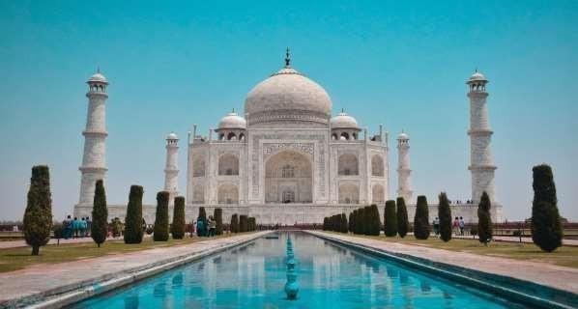
DÍA 04: | DELHI - AGRA

In the morning, depart by road for Agra – the city of the Taj Mahal.

Upon arrival in Agra, transfer to your hotel.

Renowned for being home to one of the Seven Wonders of the World, the Taj Mahal, as well as for its

historical monuments, magnificent architecture, and the beauty of its marble, Agra stands out as one of

India's main tourist destinations.

The city is famous for its marble inlay work, crafted by artisans whose expertise dates back to the Mughal

era. Agra's handicrafts also include carpet making, gold embroidery, and leather shoes. After checking into

your hotel, visit the Agra Fort.

Built during the reign of Akbar, the third Mughal emperor, this imposing fort of red sandstone

houses the magnificent Pearl Mosque in white marble, as well as the palaces, halls, courtyards, and

fountains built by his sons and successors, Jahangir and Shah Jahan.

It was here, in fact, that Shah Jahan spent the last years of his life, imprisoned by his own son,

Aurangzeb.

Overnight stay at the hotel.

DÍA 05: | AGRA – JAIPUR via Fatehpur Sikri (239Kms / 4h30Mnts)

On the way to Fatehpur Sikri.
Fatehpur Sikri is the former royal city of Emperor Akbar, now deserted. This impressive and remarkably well-preserved citadel became his capital in 1571. Here, you can visit the mosque, designed to accommodate 10,000 worshippers, as well as the palaces, residences, and audience halls, all built of ornamental red sandstone. Akbar left Fatehpur Sikri in 1584 to consolidate his outlying territories, leaving the city as we see it today—in a state of almost perfect preservation.
Then, we continue on the road to Jaipur.

Jaipur, the capital of the Rajput state of Rajasthan, is famous for its architectural wonders and rich
cultural heritage. Adorned with pink sandstone palaces, majestic forts, and lush gardens against the picturesque backdrop of the Aravalli Hills, Jaipur embodies both the charm of India's glorious past and the sophistication of a thriving metropolis. The city was founded in 1727 by Maharaja Sawai Jai Singh II, when he decided to move his capital from Amer to Jaipur. A great architect, astronomer, and passionate scientist, he designed his capital with remarkable geometric precision, making Jaipur one of the best-planned cities in India.

In the evening, stroll through the famous local Bapu Bazaar, renowned for its colorful textiles,
jewelry, and traditional handicrafts.

Overnight at the hotel.

DÍA 06: | JAIPUR
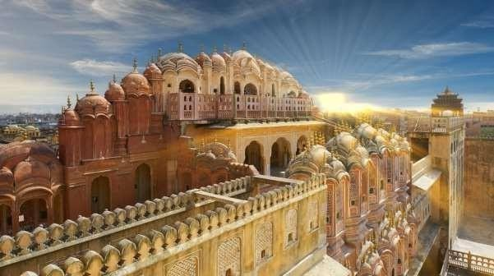

Breakfast. At the scheduled time, we will visit Amber Fort. Amber Fort is a palace complex whose construction was begun by Man Singh I in 1592. Its formidable exterior hides an inner paradise where a beautiful fusion of Mughal and Hindu architectural styles prevails. The fort, completed in the early 18th century, took 100 years to build and today, although abandoned, offers a fascinating glimpse into the lifestyle of the Mughal families. We will continue with a visit to Hawa Mahal, the "Palace of Winds," built in 1799 by Maharaja Sawai Pratap Singh. The palace has five stories and is constructed of red and pink sandstone. The facade facing the street has a total of 953 windows, designed to allow the wind to circulate and thus keep the palace cool in the summer. We will then visit the City Palace, the historic residence of the maharajas, a beautiful blend of Mughal and traditional Rajasthani architecture. The City Palace occupies one-seventh of the area of ​​the walled city. It houses the Chandra Mahal, the Shri Govind Dev Temple, and the City Palace Museum. Finally, we will visit Jantar Mantar, undoubtedly the largest and best-preserved of the five astronomical observatories built in India by Jai Singh II, who was known for his passion for astronomy. This observatory consists of instruments of extraordinary size and is still in use. Afterward, we will return to the hotel. Overnight at the hotel.

DÍA 07: | JAIPUR – PUSHKAR (142Kms / 2h45mnts)

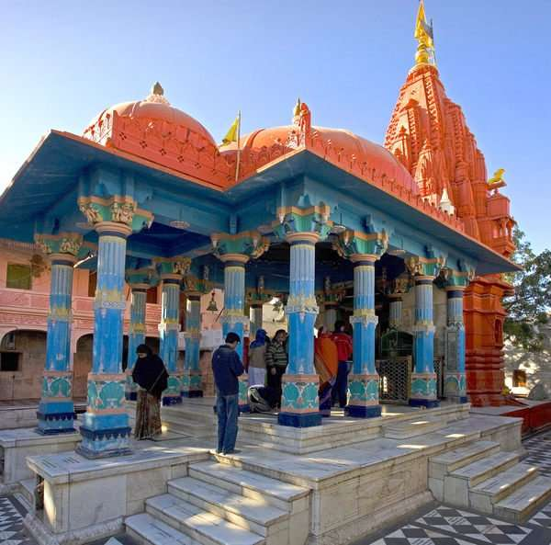
Morning after breakfast drive to Pushkar. Upon arrival check in at hotel in Pushkar.
Afternoon proceed for sightseeing tour of Pushkar. The sacred town of Pushkar is best known for its revered Brahma Temple, a rare shrine that draws pilgrims throughout the year. Beyond its spiritual aura, Pushkar comes alive during the famous Cattle and Camel Fair, held annually in the month of Kartik (October/November). This vibrant festival attracts thousands of visitors from across the world, offering a colourful blend of culture, tradition, and rural charm.

Overnight stay at Pushkar hotel

DÍA 08: | PUSHKAR – JODHPUR (189Kms / 3h 33mn)
After breakfast, depart by road for Jodhpur – the Blue City.
In the afternoon, we will visit Mehrangarh Fort and Jaswant Thada. Mehrangarh Fort is a majestic 15th-century fort located in Jodhpur, Rajasthan, built by Rao Jodha on a 120-meter-high hill. Nicknamed the "Citadel of the Sun," it is one of the largest forts in India and a symbol of Rajput royal heritage. The fort is famous for its impressive architecture, housing magnificent palaces, a museum rich in royal artifacts, and thick, imposing walls. It also offers spectacular views of the "Blue City" stretching out below.
Overnight stay at the hotel.

DÍA 09: | JODHPUR – UDAIPUR VIA RANAKPUR (249Kms / 5h 15mn)
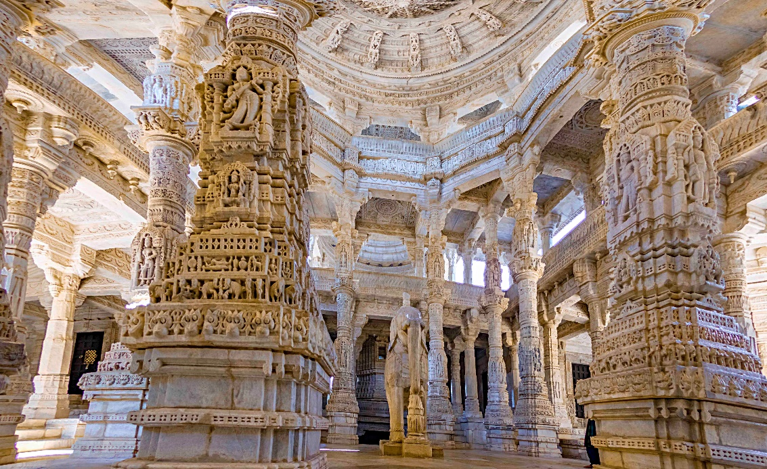
Morning after breakfast drive to Udaipur enroot visiting Ranakpur : Located about 90 km from Udaipur, Ranakpur is home to the largest Jain temple complex in India, dating back to the 15th century. The main temple, dedicated to Adinath, the first Tirthankar, is renowned for its breathtaking artistry. Every surface—from walls and domes to ceilings and pillars—is adorned with intricate carvings depicting mythological figures, floral motifs, and geometric patterns. The complex features 1,444 exquisitely carved marble pillars, each one unique, showcasing an extraordinary level of craftsmanship. Please note: Temples open at 1200 hrs. Leather belts, footwear, bare legs, and black clothing are not permitted within the premises.

Set amidst the serene Aravalli hills of southern Rajasthan, Udaipur, often called the City of Sunrise, is celebrated as one of India’s most romantic destinations. The city presents a captivating panorama of shimmering lakes, elegant marble palaces, lush gardens and rolling green hills—earning it the enduring title of “The Venice of the East.” Founded in 1568 by Maharana Udai Singh II, Udaipur was conceived as a traditionally planned, fortified city adorned with magnificent palaces, ornate temples and stately havelis. Over the centuries, it also flourished as a thriving centre for performing arts, painting and traditional crafts, nurturing a rich cultural legacy that continues to enchant visitors today.

Upon arrival check in at hotel in Udaipur. Rest of the day at leisure.

Overnight stay at Udaipur hotel.

DÍA 10: | UDAIPUR
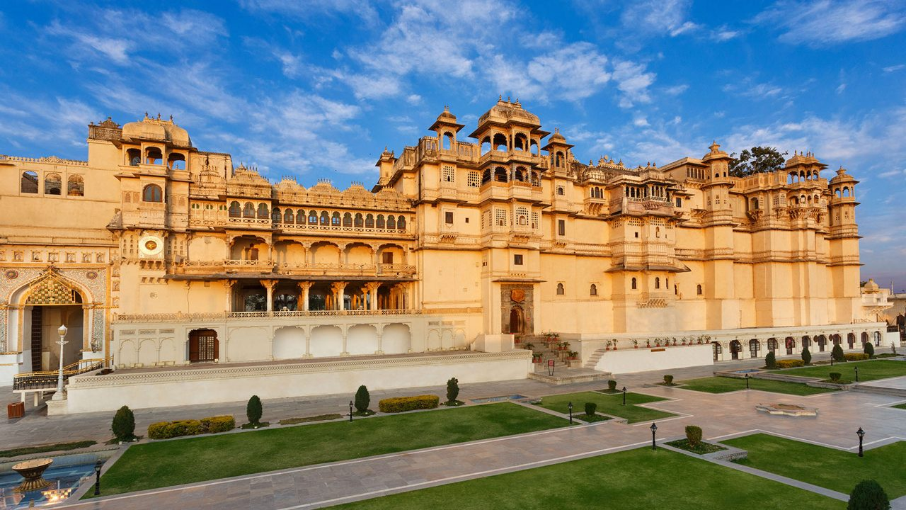
Begin your half-day sightseeing tour of Udaipur with a visit to the City Palace and Museum, the largest palace complex in India and an exquisite fusion of Mughal and Rajput architectural styles. Continue to the 17th-century Jagdish Temple, an important Hindu shrine known for its stunning carvings and towering shikharas. Drive along the serene shoreline of Fatehsagar Lake before exploring Sahelion ki Bari—the enchanting Garden of the Maids of Honour—adorned with delicately carved marble pavilions, sparkling fountains and lush lotus pools. Conclude your tour with a visit to the Bharatiya Lok Kala Mandir, the Folk Art Museum, which showcases Rajasthan’s vibrant cultural traditions through its rich collection of costumes, masks, puppets and folk artefacts.

Afternoon enjoy a serene boat ride on Lake Pichola, a picturesque expanse stretching 4 km in length and 3 km in width, framed by rolling hills, majestic palaces, elegant havelis, ancient ghats, and lakeside temples. As you glide across its tranquil waters, take in unforgettable views of Udaipur’s enchanting skyline. The experience is enhanced with a visit to Jag Mandir Island, renowned for its magnificent Gul Mahal Pavilion, an exquisite symbol of the city’s royal splendour.

Overnight at Udaipur hotel

DÍA 11: | UDAIPUR – DELHI (FLIGHT)

On time transfer to airport to board flight for Delhi. Meeting and assistance at Delhi domestic airport and transfer to hotel. Upon arrival check in at hotel in Delh.

Overnight stay at Delhi hotel.

DÍA 12: | DELHI – KATHMANDU (FLIGHT)

On time transfer to airport to board flight for Kathmandu. Meeting and assistance upon arrival at Kathmandu airport and transfer to hotel. Upon arrival at Tribhuwan International airport Kathmandu, meet and assist by our representative and transfer to hotel.

Kathmandu is the capital of Nepal and the largest urban agglomerate of Nepal. The agglomerate consists of Kathmandu Metropolitan City at its core, and its sister cities Patan, Kirtipur, Thimi, and Bhaktapur. It also includes the recently recognized urban areas of Shankhapur, Karyabinayak, Champapur, Banepa, Dhulikhel and Panauti. According to a census conducted in 2011, Kathmandu metropolis alone has 975,453 inhabitants, and the agglomerate has a population of more than 2.5 million inhabitants. The city stands at an elevation of approximately 1,400 meters (4,600 ft) in the bowl-shaped Kathmandu Valley of central Nepal. It is surrounded by four major mountains: Shivapuri, Phulchoki, Nagarjun and Chandragiri.

Overnight at Hotel in Kathmandu.

DÍA 13: | KATHMANDU

Morning after breakfast proceed for full day sightseeing tour of Kathmandu visiting Kathmandu Durbar Square: Kathmandu’s number one tourist attraction swarms with life. Though a few of the square’s 50-plus monuments date from the 12th century, most are from the time of the Malla Kings. Probably the most famous building here is the Kumari Bahal, a building richly decorated with beautiful woodcarvings, which is home to the Royal Kumari, the Living Goddess, and a manifestation of the great goddess Durga. Nearby the former Royal Palace is a Mall Dynasty dwelling, once considerably more extensive than today. Within, the courtyard Nassal Chowk, originally hosted dramatic dance performances, now it is the coronation site of the Shah kings and contains some of the finest wood carvings you will see anywhere in the kingdom. The 14th century Jagannath Mandir is the oldest temple in the area, its steps carved with inscriptions in many languages, nearby Taleju Mandir is one of the largest and finest temples in the Valley.

Visit Kumari Temple – Living Goddess: Kumari, A ‘living goddess’ made a rare public appearance to take center stage at a religious festival in Nepal.A Kumari, meaning virgin in Nepalese, is a young prepubescent girl, considered by devotees to be incarnations of the Hindu goddess of power, Kali.

Swayambhunath: The most ancient and enigmatic of the Valley’s holy shrines the golden-spired stupa of Swayambhunath tops a wooded hillock. Records of its history date as far as the 5th century, but its origins are believed to be older. It is the Kathmandu Valley’s most sacred Buddhist shrine and whilst its worshippers include the Vajrayana Buddhists of northern Nepal and Tibet, Newari Buddhists are the most fervent devotees.

Patan: Patan, the ancient city, once a kingdom in itself, is situated across the Bagmati River to the south of Kathmandu. Patan Durbar Square offers the finest display of Newari urban architecture in Nepal. There are temples devoted to Shiva, Krishna, Ganesh and Vishnu all actively visited by residents and visitors. At the northern end of the square the ancient sunken water tap has been restored and is still in use with young girls filling huge jugs from the carved Stone waterspouts. The courtyards of the Royal Palace with their ornamented windows, columned arcades, shrines and sunken royal bath are amongst the loveliest in all Kathmandu.

Overnight stay at Kathmandu hotel.

DÍA 14: | KATHMANDU

Morning after breakfast proceed for sightseeing tour of Pashupatinath: situated approx. 4 km east of Kathmandu city, Pashupatinath temple is one of the holiest Hindu temples dedicated to Lord Shiva. Situated, amidst a lush green natural setting on the bank of the sacred Bagmati River, the temple built in pagoda style has gilted roof and richly carved silver doors. Visitors will be permitted to view the temple from the east bank of river Bagmati, entrance in the temple being strictly forbidden to all non Hindus. Pashupatinath is the centre of annual pilgrimage on the day of Shivratri which falls in the month of February/March. Behind the temple are the cremation grounds.

Boudhanath: This stupa, approx. 7 km east of Kathmandu city is one of the biggest in the world of its kind. It stands with four pairs of eyes in the four cardinal direction keeping watch for righteous behavior and human prosperity. This Buddhist stupa was built by King Man Deva at the advice of Goddess Mani Jogini. It is built on an octagonal base inset with prayer wheels. The shrine is ringed by houses of Lamas or Buddhist priests.

PM: Sightseeing tour of Bhaktapur Durbar Square along with a heritage walk through its medieval alleys. Visit a Local Family to gain insight into the lifestyle of the locals.

Bhaktapur Durbar Square: Bhaktapur lies only at the distance of 13 km to the east from the capital city, Kathmandu, one can have an opportunity to experience a different world, the world full of vibrant cultures, colorful festivals, generations old craftsmanship, and on top of that it is very worthwhile experiencing its indigenous lifestyle – still preserved old houses, still practiced traditional ways of welcoming guests, still practiced culinary &amp; cutlery and many more experiences.

As you walk in, you cannot but be overcome by a feeling of inner harmony. Such is the art and architecture and the special layout here. The Palace of 55 Windows built during the period of King Bhupatindra Malla in 1754 situated to the left as you enter through the city gate, inspires admiration. The National Art Gallery is also housed inside. The palace entrance, the Golden Gate known as SunkoDhoka in Nepali is a masterpiece in repousse art. In front of the palace building is a medley of temples of various designs. Amongst the three Durbar Squares in the Valley, the Durbar Square in Bhaktapur is the best preserved one.

Overnight at Kathmandu Hotel.

DÍA 15: | DEPART KATHMANDU

On time transfer to Tribhuvan International airport to board flight for onward destinaton.

FINAL COST
Precios por persona en habitación doble / triple: Valid Until 30 Sept 2025
CATEGORIA | COSTO POR PERSONA
Para 6 personas de pago | € PP
Suplemento para vuelos (Delhi / Varanasi / Delhi) | € PP
Suplemento de entradas | € PP
TOTAL | € PP

Cena obligatoria en The Amayaa: 63 € por persona Cena obligatoria en Park Plaza: 23 € por persona

Coste basado en hoteles de 4 estrellas : Hotels Previstos
Ciudad | Hotel | Noches | Fechas
Delhi
Agra
Jaipur
Pushkar
Jodhpur
Udaipur
Delhi
Kathmandu
Total

Our prices include:

Price per person in a double room.

Room and breakfast

Transfers as per itinerary.

5 nights in Delhi on a bed and breakfast basis

2 nights in Pushkar on a bed and breakfast basis.

2 nights in Jaipur on a bed and breakfast basis.

2 nights in Agra on a bed and breakfast basis

2 nights in Varanasi on a bed and breakfast basis

Sightseeing and entrance fees as per itinerary.

Escort guide throughout the tour from arrival in Delhi until departure from Agra back to Delhi.

Local Spanish-speaking guide as per program only during sightseeing tours in Varanasi.

Government taxes.Nuestros precios incluyen:

Our prices do not include:
- Entry visa. This can be obtained online at: www.indianvisaonline.gov.in
- Guide gratuities (at the client's discretion).
- Optional travel and cancellation insurance.
- Beverages.
- Any services not mentioned as included, nor personal extras such as telephone calls, laundry, etc.

Nuestros precios no incluyen:
- Visado de entrada. Se adquiere online en: www.indianvisaonline.gov.in
- Propinas del guía (a criterio del cliente).
- Seguro opcional y seguro de cancelación
- Bebidas.
- Ningún servicio no mencionado como incluido, ni extra de índole personal, como teléfono, lavandería etc.

